BISHOP’S STORTFORD SWIMMING CLUB

TROPHY RECORD BOOK
STARTED 2023

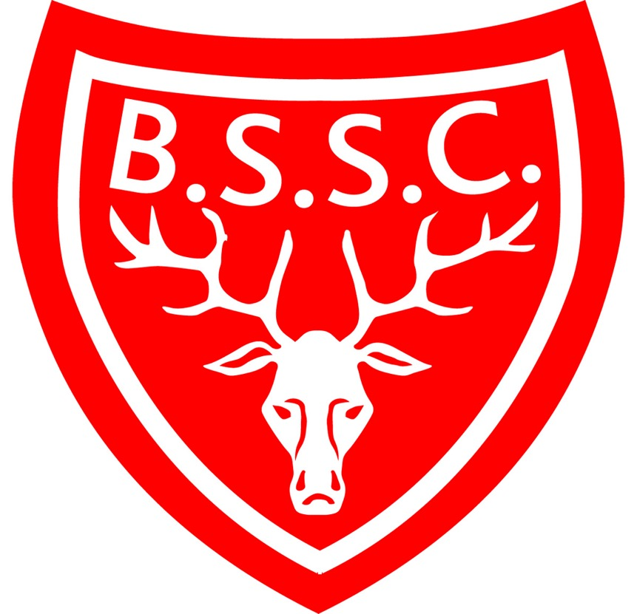

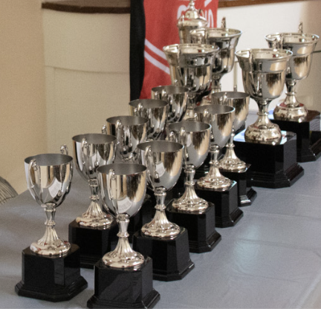

GIRLS UNDER 9

2023 – Charlotte Cass

BOYS UNDER 9

2023 – William David-Tostevin

GIRLS 10/11

2023 – Elspeth Lowe

BOYS 10/11

2023 – Noah Conroy

GIRLS 12/13

2023 – Molly Greatbatch

BOYS 12/13

2023 – Elliot Hall
GIRLS 14/15

2023 – Zoe Opiyo

BOYS 14/15

2023 – Dylan Davenport

GIRLS 16+

2023 – Niamh James

BOYS 16+

2023 – Jake Lloyd

COACHES AWARDS

MOST IMPROVED GIRL
(presented annually to the most improved girl learner)

2023 – Lois Fields

MOST IMPROVED BOY
(presented annually to the most improved boy learner)

2023 – Dylan Davenport

ENDEAVOUR AWARD GIRL
(presented annually to a girl who tries their hardest)

2023 – Catherine Els

ENDEAVOUR AWARD BOY
(presented annually to a boy who tries their hardest)

2023 – Haydn Bird

OVERALL SPORTS PERSON OF THE YEAR
(presented annually to a senior swimmer who sets a good example to younger swimmers)

2023 – Beau Riley

